**PRACTICAL 8**

**Aim :**

Explain the concept of cookies using JavaServer Pages (JSP).

**Explanation :**

We are creating cookies of username and email and adding age to the cookie for 10 hours and trying to get the variable names in **Action_cookie_main.jsp.**

When we execute the **Action_cookie.jsp,** we get two fields that is username and email and we input details and then we click on **Submit** button.

We get the output from **Action_cookie_main.jsp** where variables are stored in the cookies on the client side and the details are shown on the page.

**Code : Action_cookie.jsp file**

<%@ page language = "java" contentType = "text/html;

    charset = ISO-8859-1"

    pageEncoding = "ISO-8859-1"

%>

<!DOCTYPE html PUBLIC "//W3C//DTD HTML 4.01 Transitional//EN"

"http://www.w3.org/TR/html4/loose.dtd">

<html>

<head>

<meta http-equiv = "Content-Type" content = "text/html;

    charset = ISO-8859-1">

<title>Aftab Cookie</title>

</head>

<body>

<form action = "Action_cookie_main.jsp" method = "GET">

Username : <input type = "text" name = "username">

<br />

Email : <input type = "text" name = "email" />

<input type = "submit" value = "Submit" />

</form>

</body>

</html>

**Code : Action_cookie_main.jsp file**

<%@ page language = "java" contentType = "text/html;

    charset = ISO-8859-1"

    pageEncoding = "ISO-8859-1"

%>

<!DOCTYPE html PUBLIC "-//W3C//DTD HTML 4.01 Transitional//EN"

"http://www.w3.org/TR/html4/loose.dtd">

<%

    Cookie username = new Cookie("username", request.getParameter

("username"));

    Cookie email = new Cookie("email", request.getParameter("email"));

    username.setMaxAge(60*60*10);

    email.setMaxAge(60*60*10);

    response.addCookie( username );

    response.addCookie( email );

%>

<html>

<head>

<meta http-equiv = "Content-Type" content = "text/html;

    charset=ISO-8859-1">

<title>Aftab Cookie JSP</title>

</head>

<body>

<b>Username : </b>

    <% = request.getParameter("username") %>

<b>Email : </b>

    <% = request.getParameter("email") %>

</body>

</html>

**Screen Shots :**

**After Executing Action_cookie.jsp file**

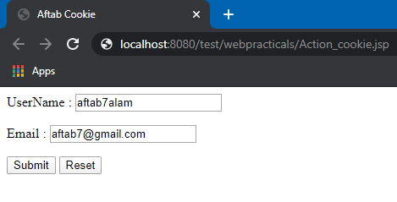

**After executing Action_cookie_main.jsp file**

